# Byron Laferriere

Professor DiMarzio

# CS 310 Changelog Template

All notable changes made from the tutorial exercises for CS 310 using the Calculator application will be documented in this file. Each version will match to a separate tutorial. Remember to start at the end of this file and work your way up. The most recent change will be located at the top of this document.

## Version 1.0.12 < 2021-08-14>

Note: Student Playlist – Development Setup/Outline/Completion

Major Changes:

* Cloned the Repo to make a Local Version, ran the code and tests before editing

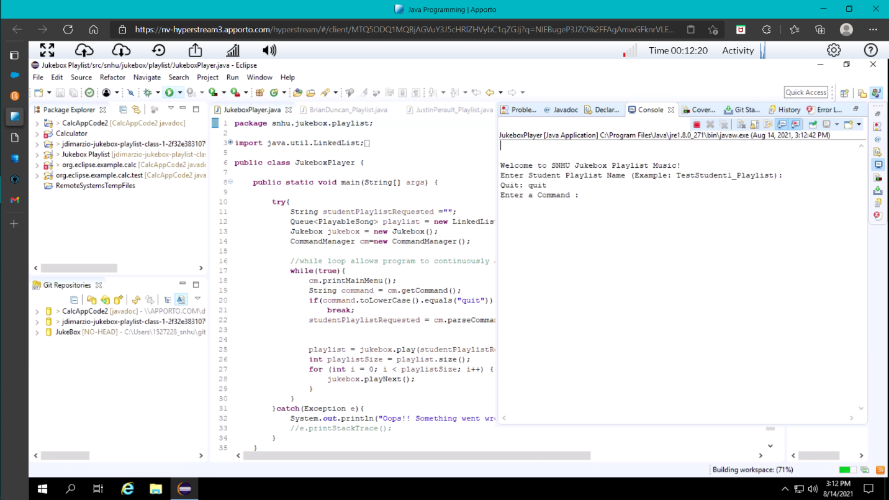

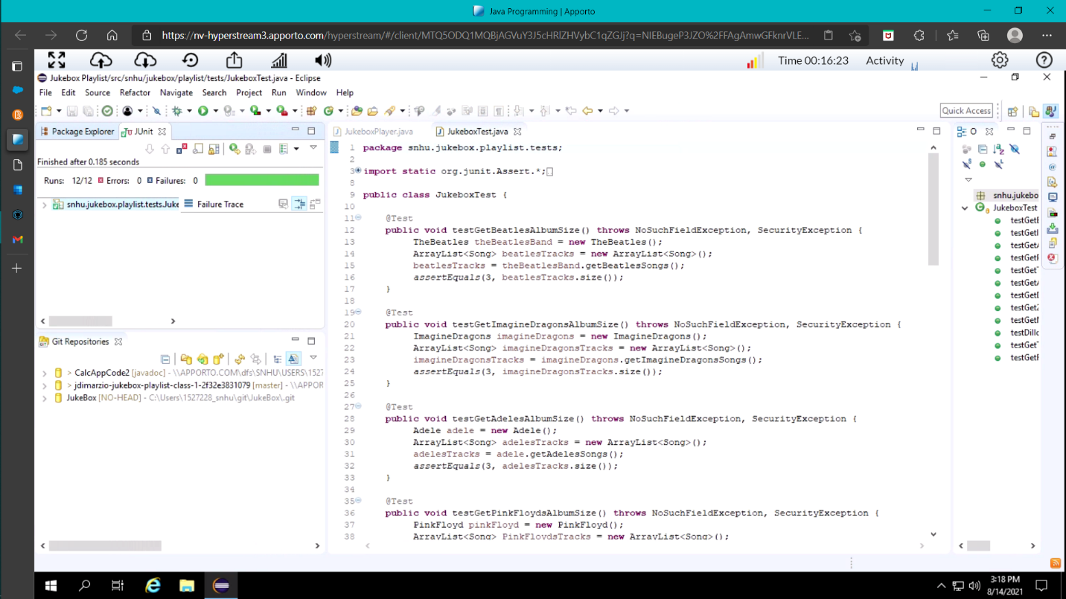

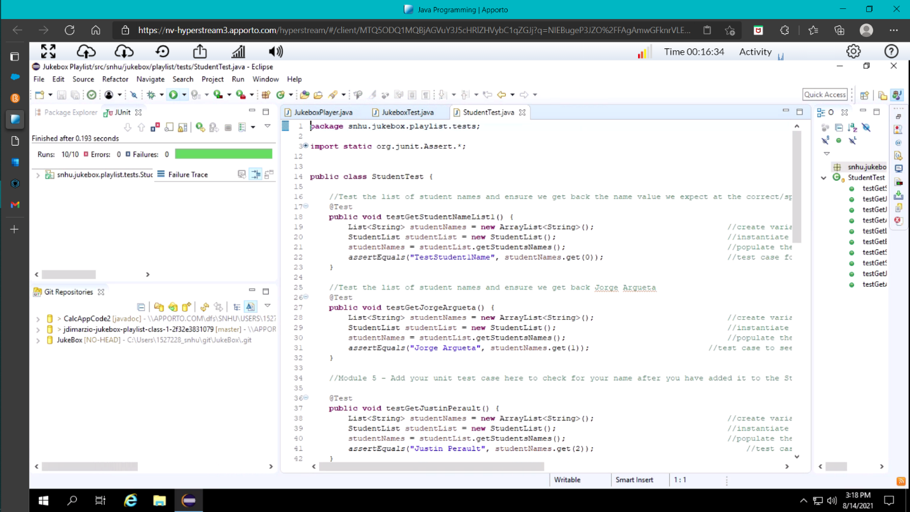

Minor Changes:

* Creating personal playlist

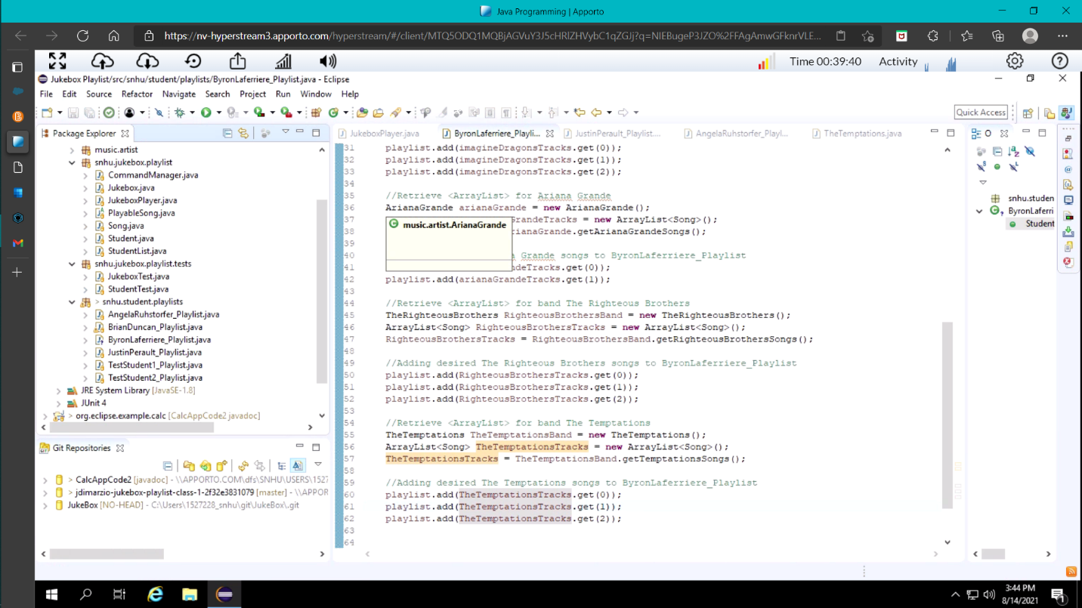

* Adding personal profile

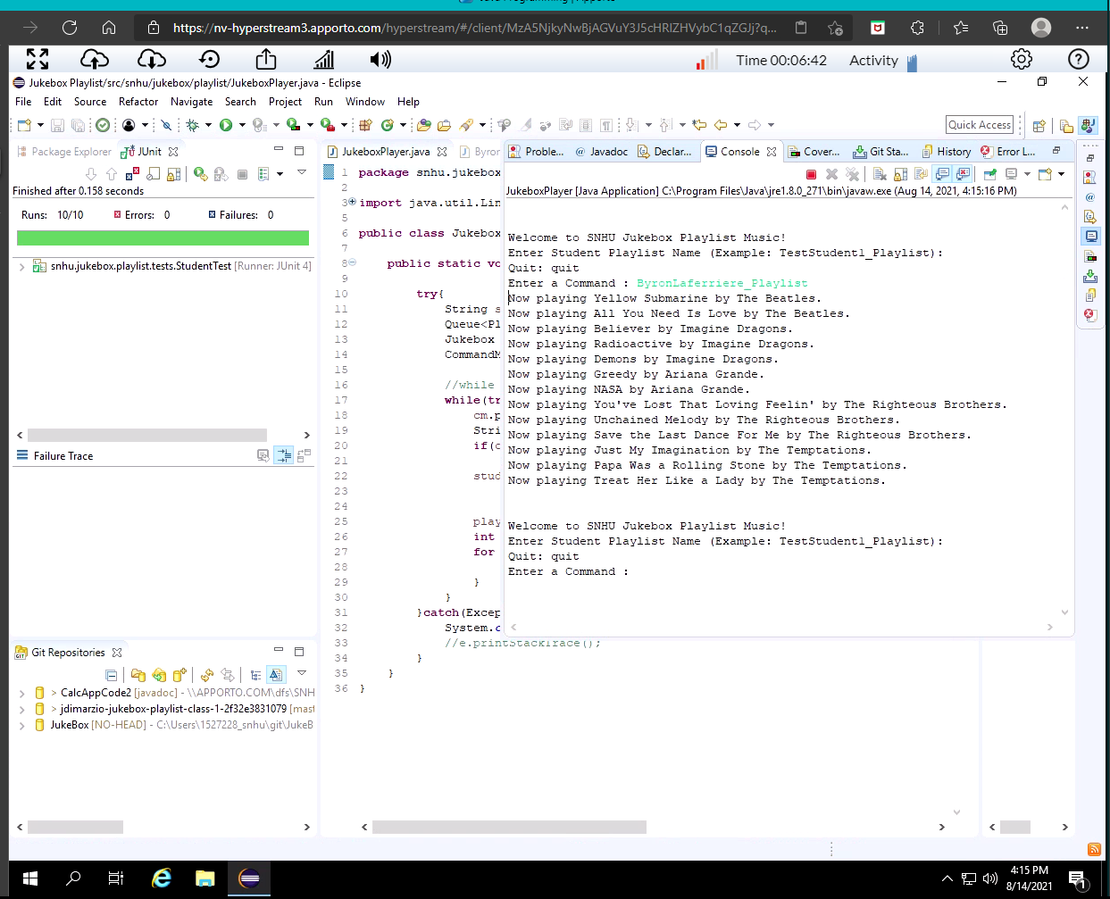

Bug Fixes:

* Pushed new playlists and features to shared repo

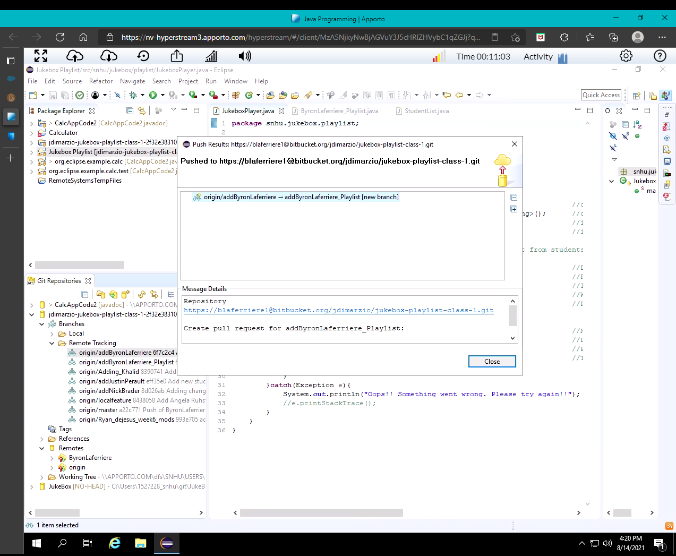

## Version 1.0.11 <2021-08-10>

Note: Jukebox Playlist – Development Setup/Outline/Completion

Major Changes:

* Debugged and ran the new project

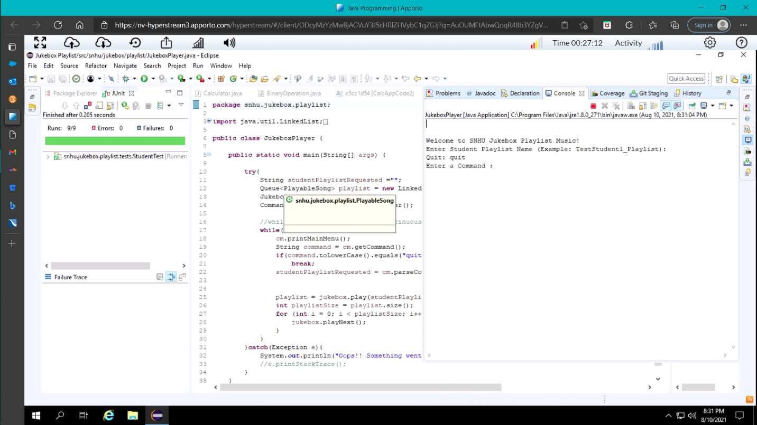

* Ran all tests in new project

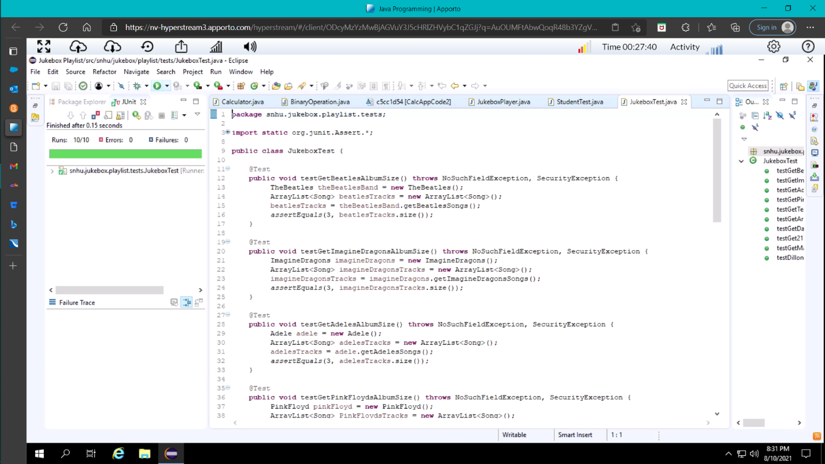

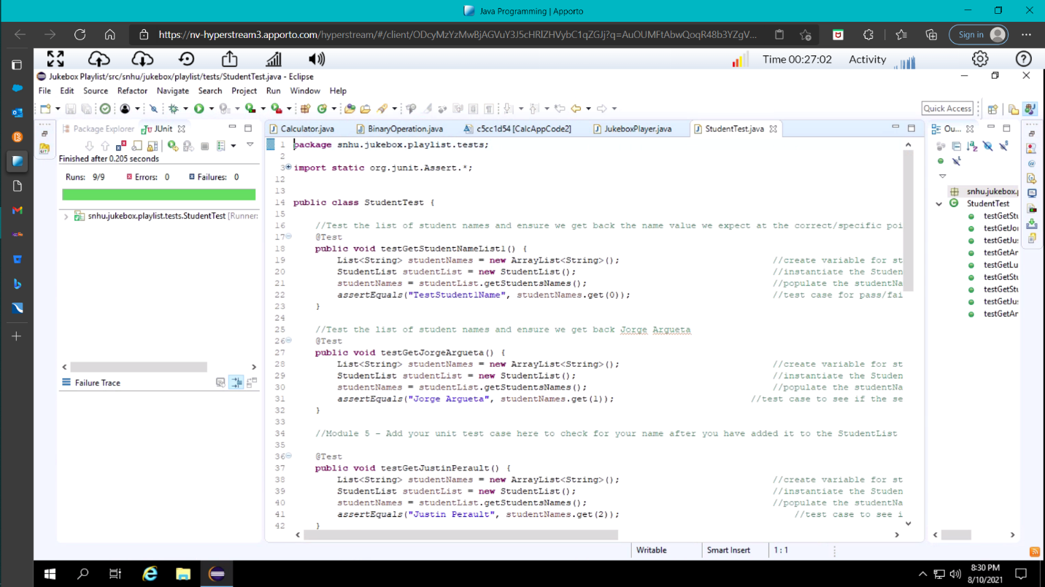

Minor Changes:

* Added two new bands to the music.artists package

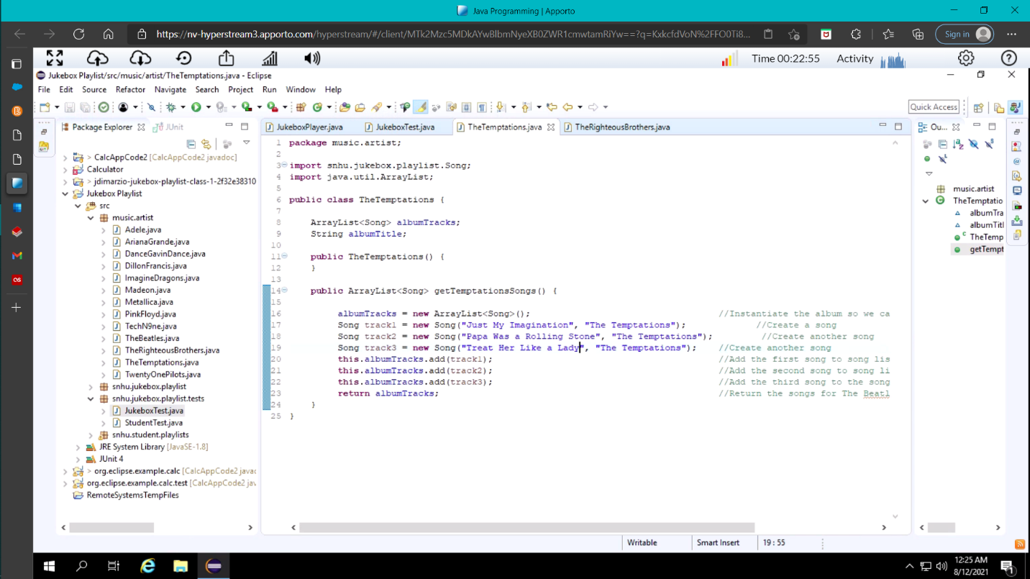

* Tested new bands and songs to ensure that code was working

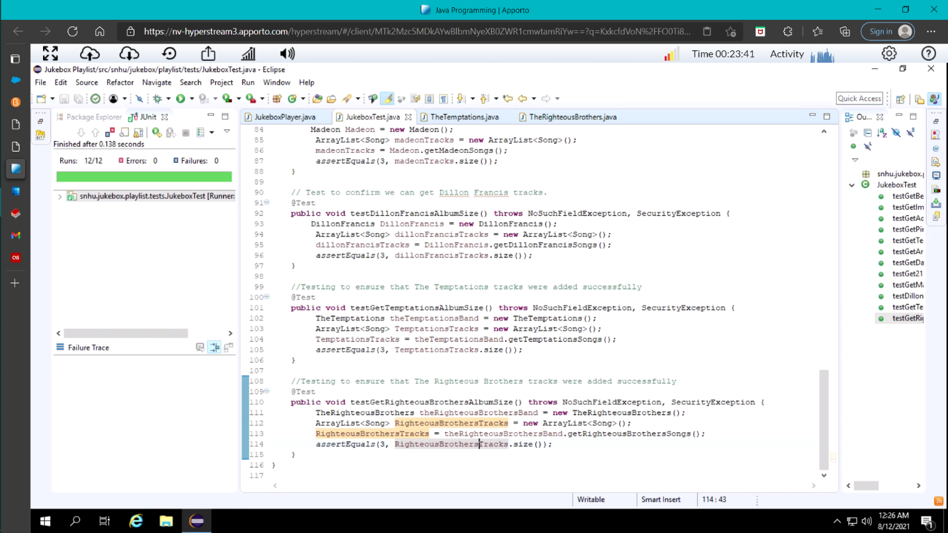

Bug Fixes:

* New Branch added to BitBucket

## Version 1.0.10 <2021-08-10>

Note: Tutorial Ten – Stashing Changes in EGits

Major Changes:

* + Stashing Local Changes

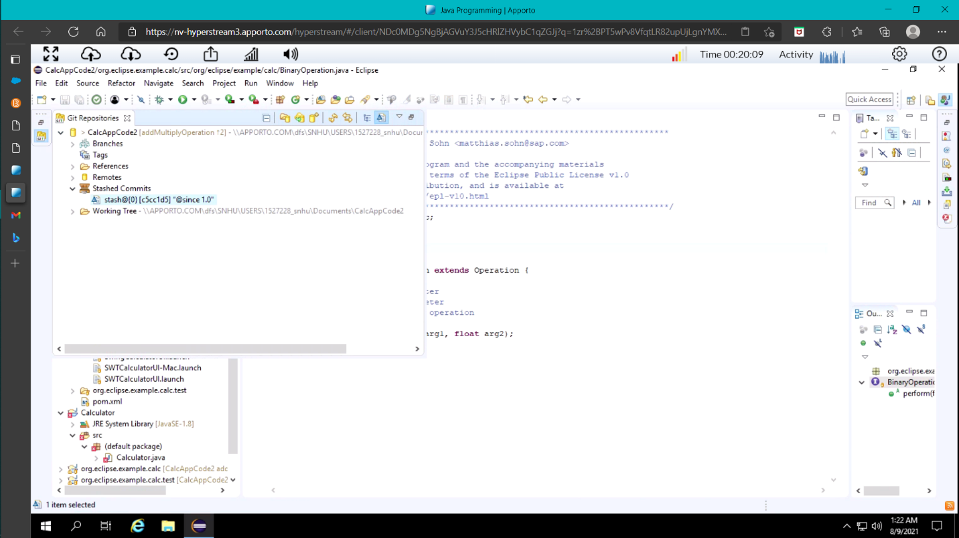

* Browsing Stashed Changes

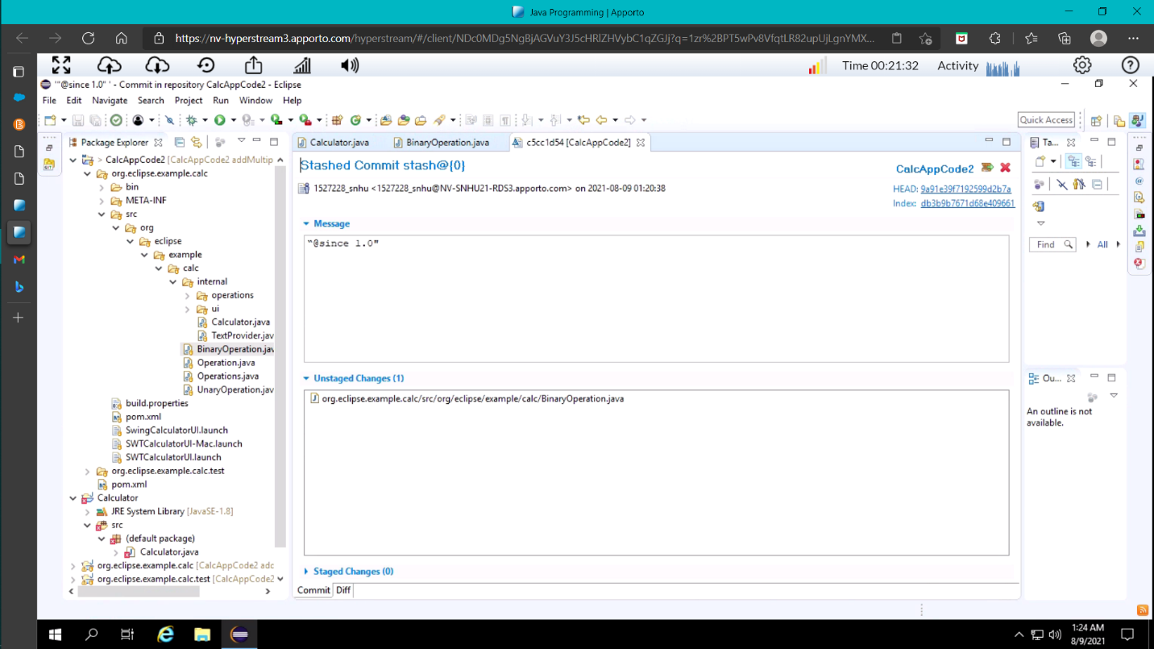

* Applying Stashed Changes

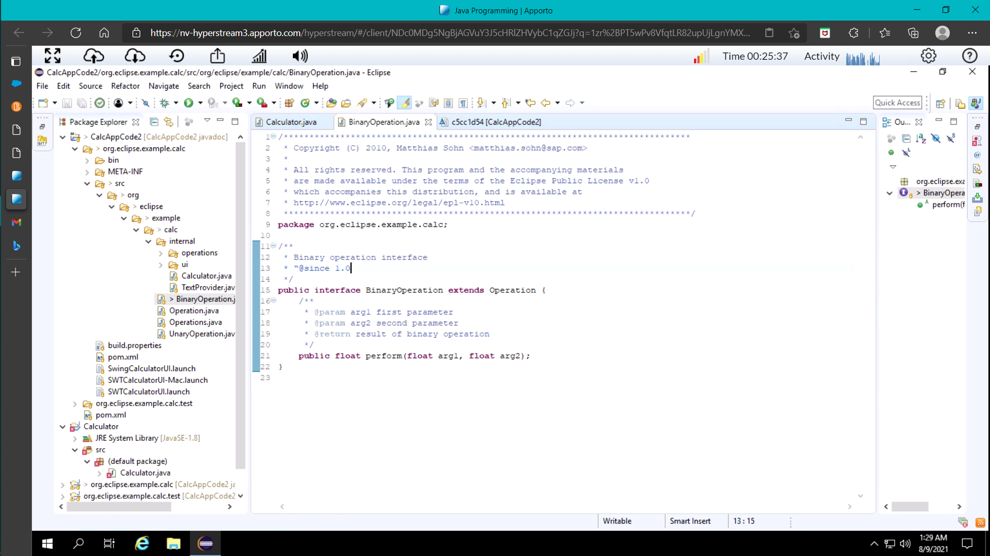

Minor Changes:

* No Minor Changes conducted

Bug Fixes:

* No Bug Fixes performed

## Version 1.0.9 <2021-08-10>

Note: Tutorial Nine – Use the Git Blame Feature

Major Changes:

* No Major Changes

Minor Changes:

* No Minor Changes

Bug Fixes:

* Enabled Show Annotation and Git Blame

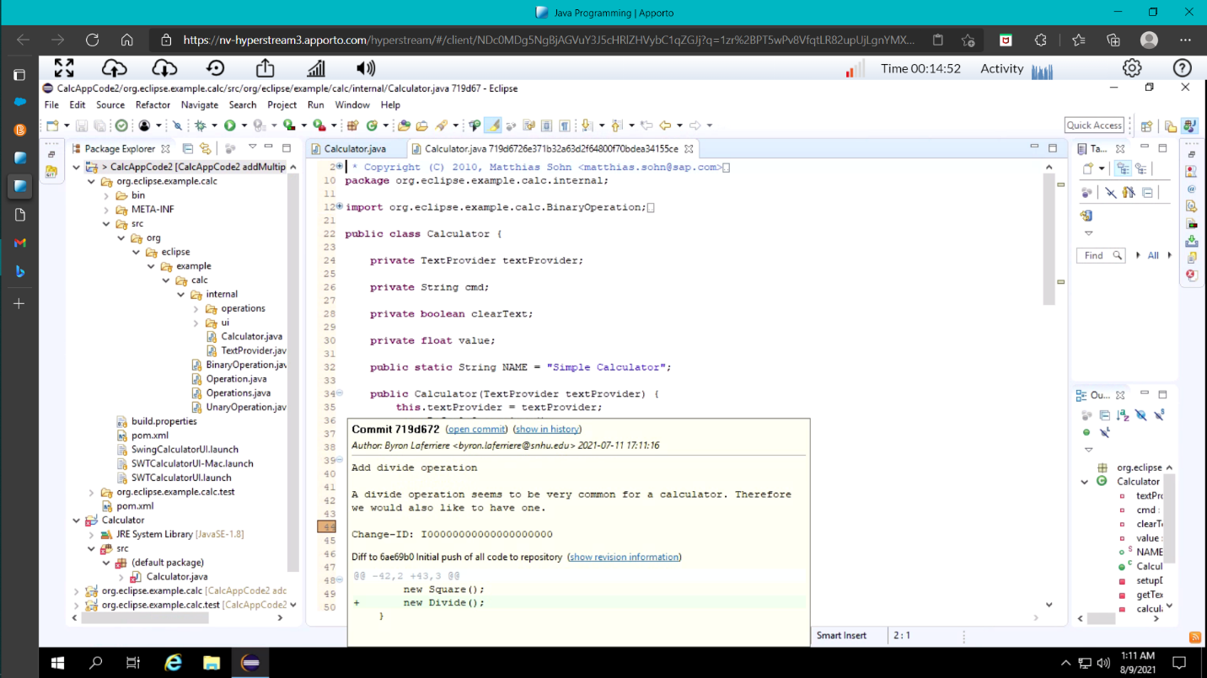

## Version 1.0.8 <2021-08-08>

Note: Tutorial Eight – Change of Series of Commits

Major Changes:

* Changed previous commit and branched from origin/master

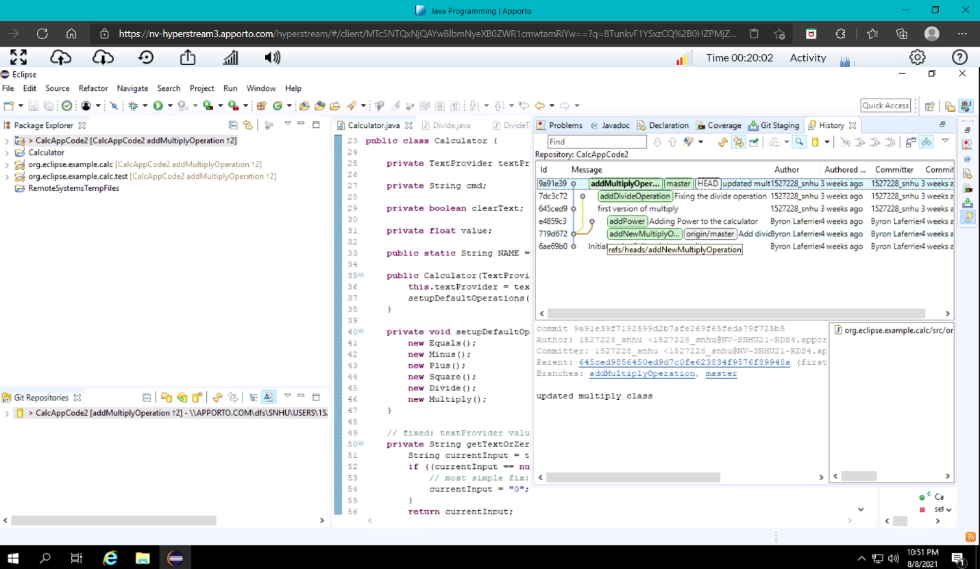

Minor Changes:

* No Minor changes conducted

Bug Fixes:

* No bug fixes performed here.

## Version 1.0.7 <2021-07-18>

## Note: Tutorial Seven – Reset branch to a previous state

Major Changes:

* Squash two separate commits and merge into one

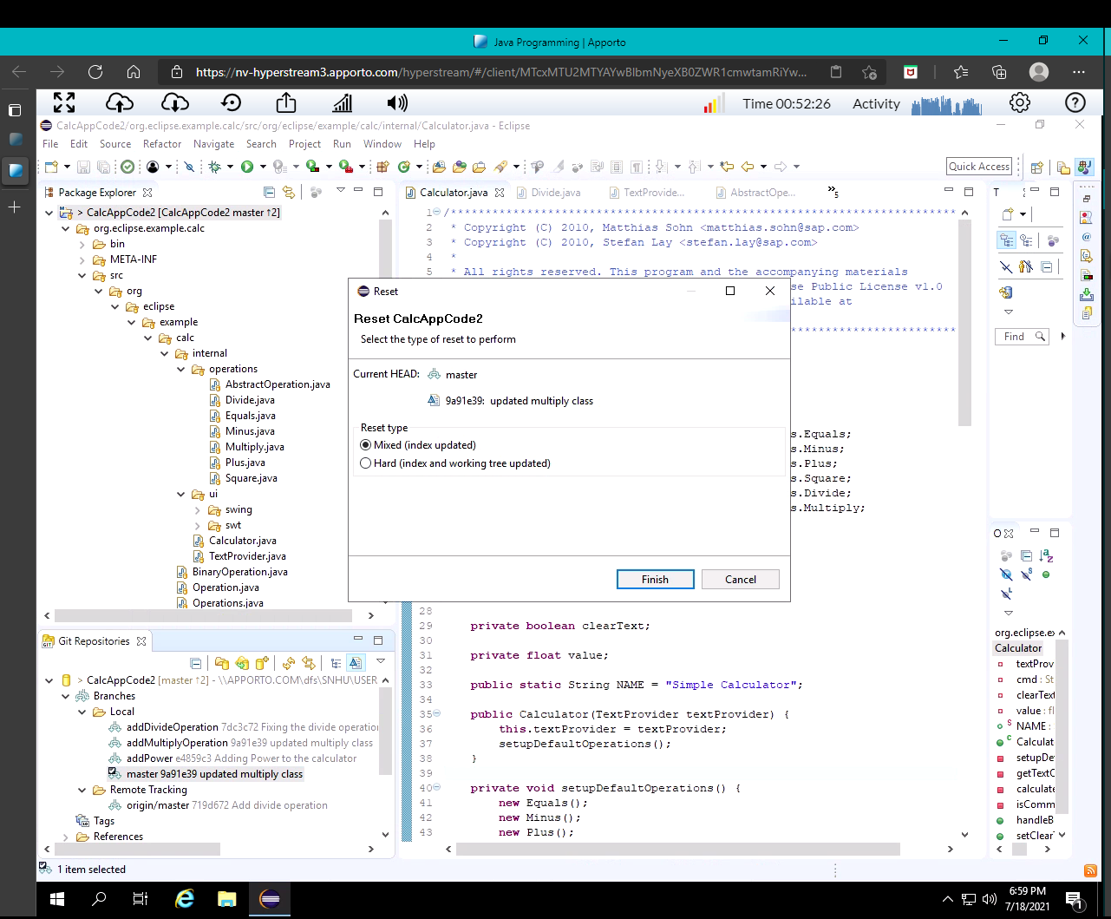

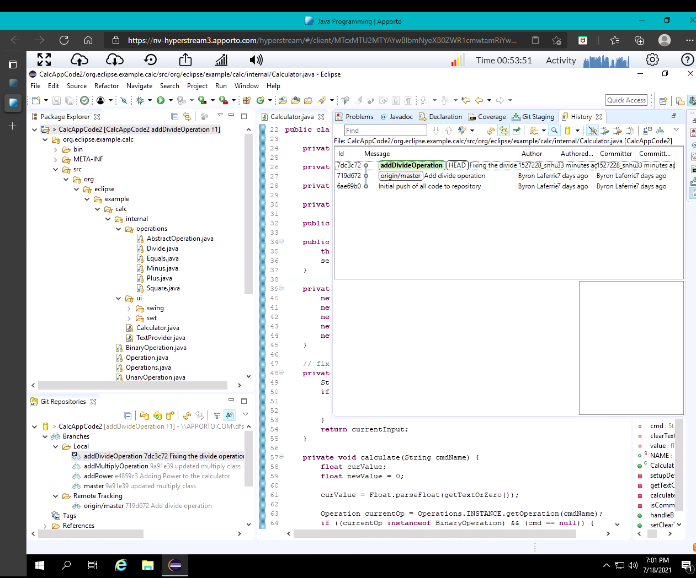

Minor Changes:

* No minor changes

Bug Fixes:

* No bug fixes

## Version 1.0.6 <2021-07-18>

Note: Tutorial Six – Merging, Rebasing, Resolving Conflict

Major Changes:

* Merge conflicting commits on master branch

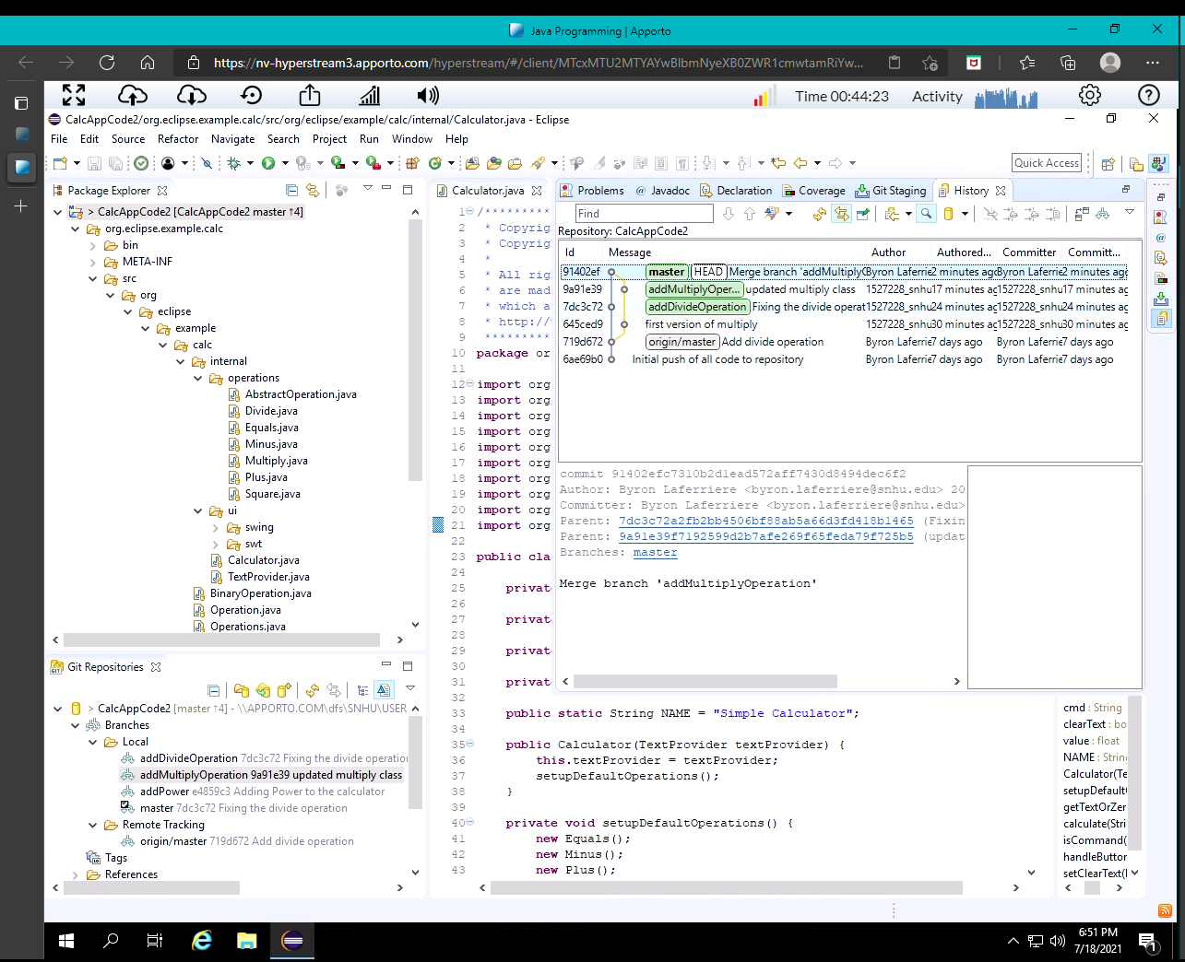

Minor Changes:

* No minor changes

Bug Fixes:

* No bug fixes

## Version 1.0.5 <2021-07-18>

Note: Tutorial Five – Fetch the latest state from upstream

Major Changes:

* No major changes conducted

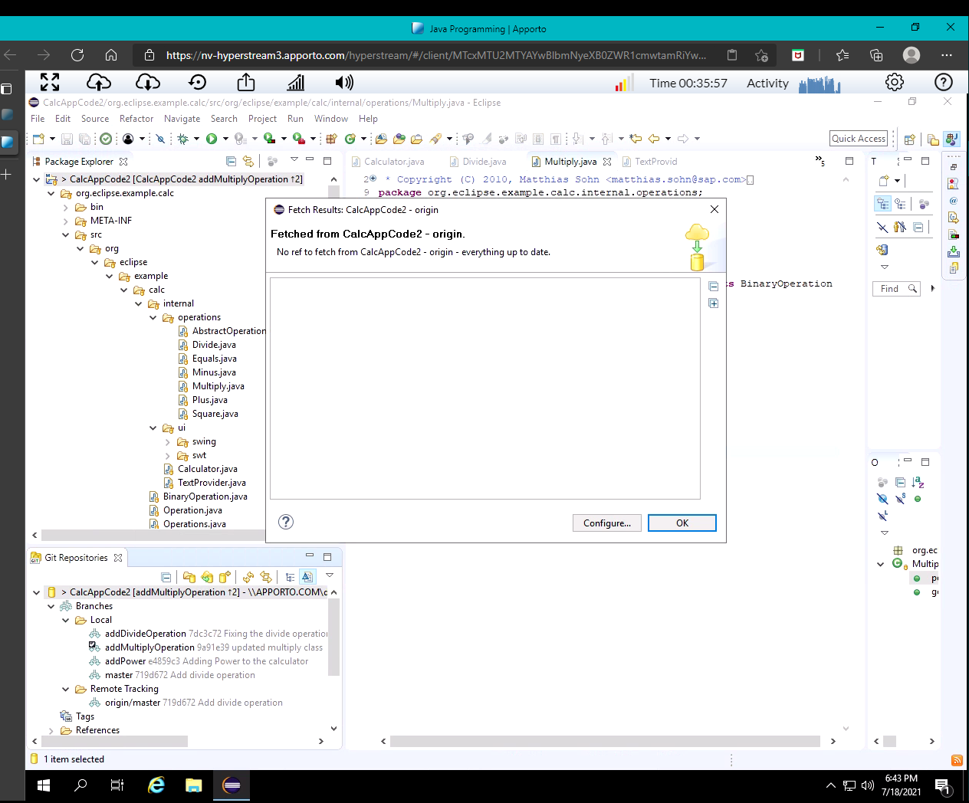Minor Changes:

* Ensured the origin/master branch is up-to-date before creating a new branch

Bug Fixes:

* No bug fixes

## Version 1.0.4 <2021-07-18>

Note: Tutorial Four – Work on Branches in Parallel

Major Changes:

* Created new branch to add in multiply features.

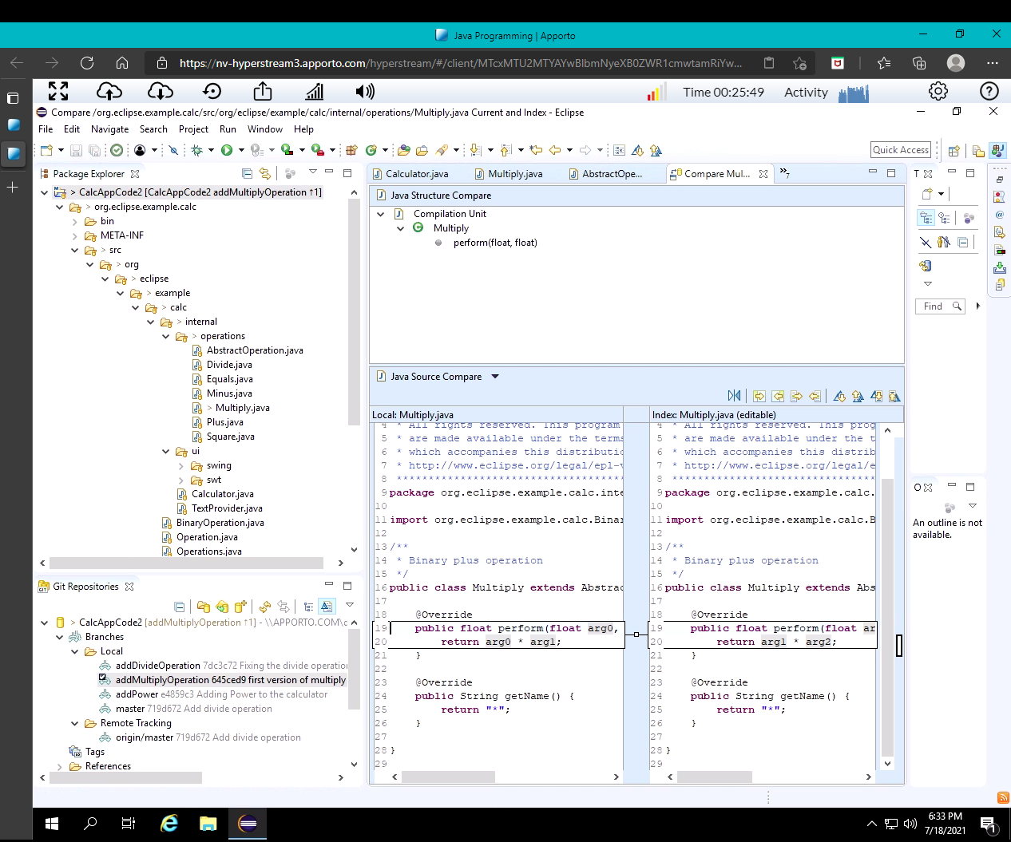

Minor Changes:

* Updated multiply to be able to practice compare mode

Bug Fixes:

* Added multiply feature to calculator

## Version 1.0.3 <2021-07-11>

## Note: Tutorial Three – Inspecting the History

Major Changes:

* Added ‘search bar’ capabilities to the History log for Git

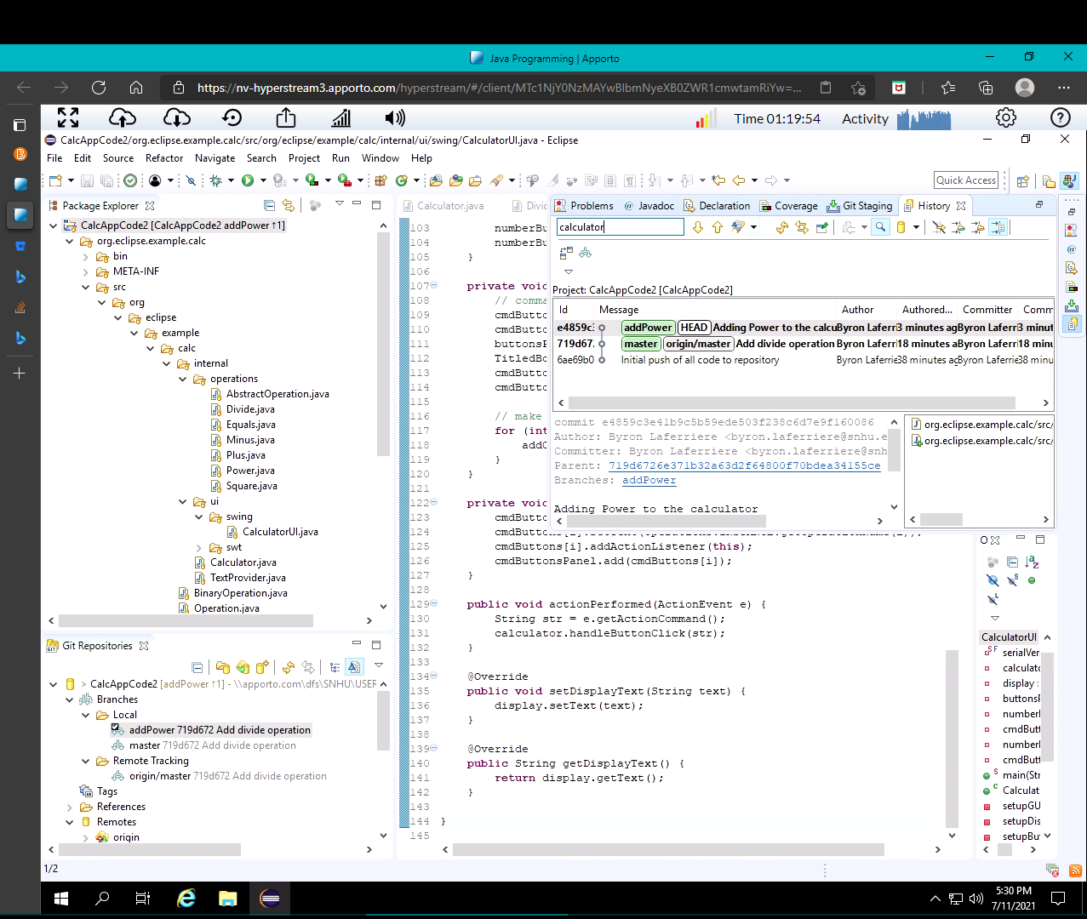Minor Changes:

* No minor changes

Bug Fixes:

* Search bar capabilities enabled for History

## Version 1.0.2 <2021-07-11>

Note: Tutorial Two – Develop Another Feature and Use Staging View

Major Changes:

* Added new feature labeled ‘Power’ to the Calculator UI.

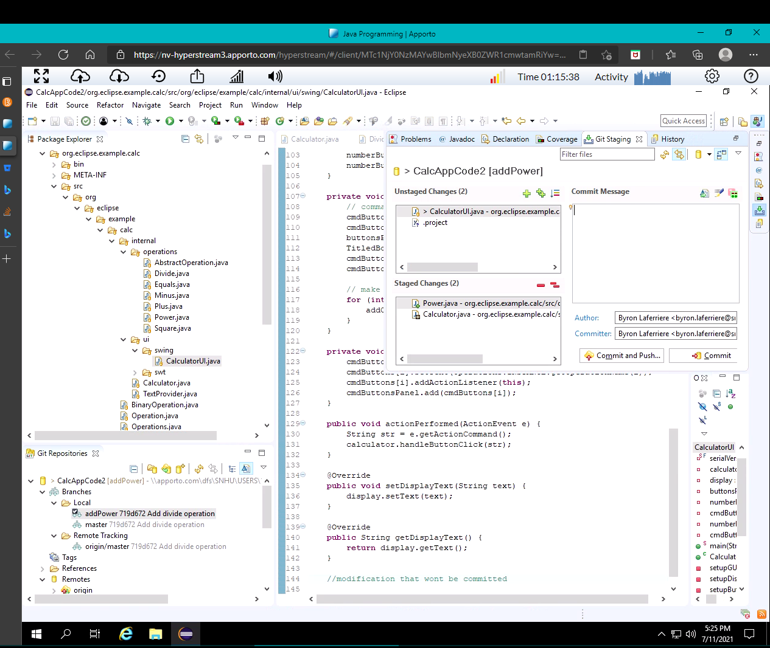Minor Changes:

* Created a new local feature branch
* Developed src for the feature
* Committed new feature to repo

Bug Fixes:

* Added power on/off capabilities

## Version 1.0.1 <2021-07-11>

Note: Tutorial One – Develop a Feature Bug Fix

Major Changes:

* Added divide operation to the calculator features.

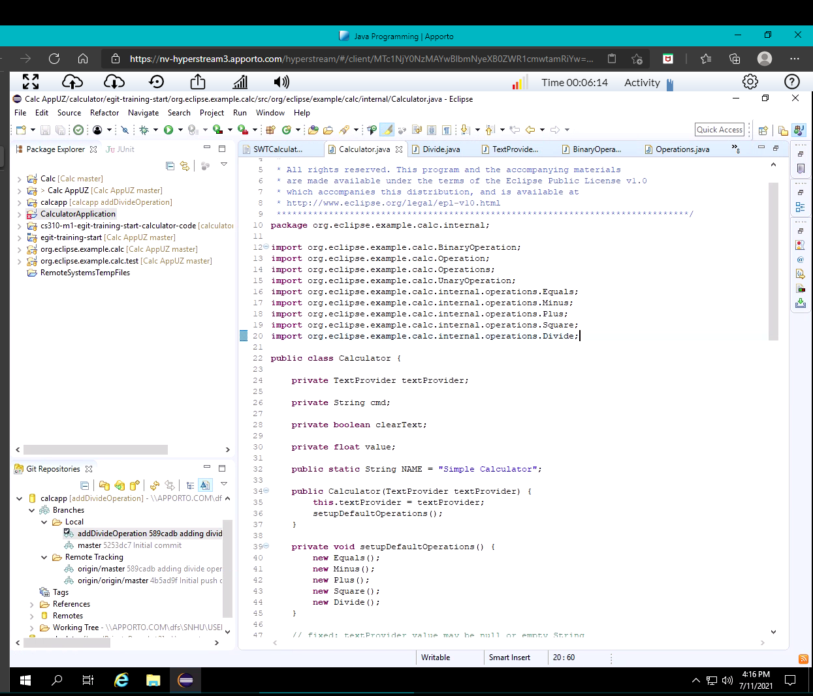

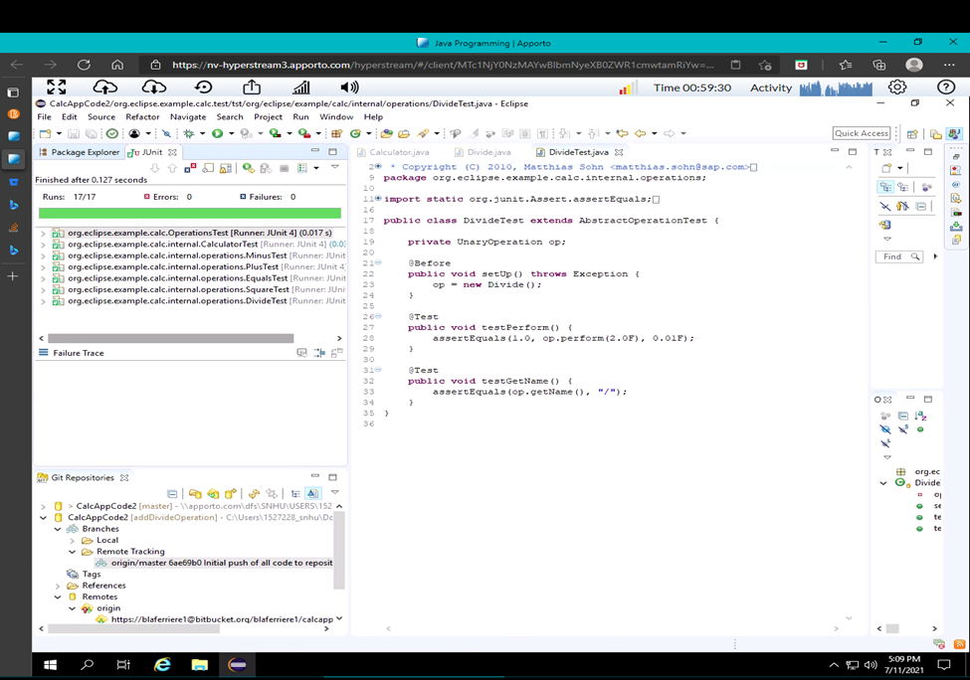

Minor Changes:

* Added divide.java
* Used import command to call class
* Added corresponding lines to setupOperations

Bug Fixes:

* Added division capabilities